Zoom Guide
How to access Zoom:
- If working from a computer, you can go to http://zoom.us/ to download the application to your computer.
- If working from a smart phone, you can download the Zoom application from either the Android store or the Apple store by searching “Zoom cloud meetings”.

An account is not required, but they are free. When setting one up, do not use your full name in order to protect your privacy.

For a full list of system requirements or other questions, you can access Zoom’s support center.

Setting up your space
- Set up your location in a quiet place devoid of distractions or interruptions from others where you will be comfortable. If using a smart device, turn off notifications from other apps.
- Remember, others will see you! Make sure that you have good light (natural light is best) and that you don’t have anything distracting or private in the background, and wear appropriate clothing. For example, casual clothing that you would normally wear in public settings is fine.
- Make sure you have a stable connection to the internet.
- Ensure your device is fully charged or plugged in so that it will last 90 minutes.
- If able, use headphones or a headset to prevent audio feedback. If this is not possible, mute your microphone when not speaking.
- Put the camera at eye level and remember to look at the camera while talking!

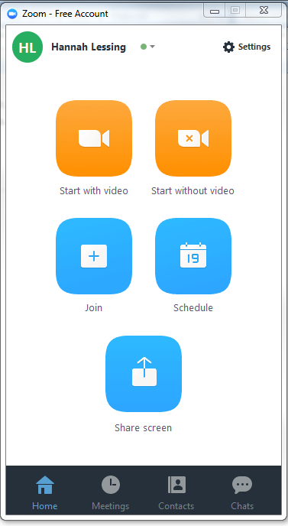
Joining the meeting
1. Either through the app or from the desktop application, you can join a meeting with video or without video (you can enable video later after joining). Please remember for these sessions, you must have video enabled.
2. When prompted, enter the meeting ID. Your meeting ID was provided to you by a research staff member and can be accessed on your portal. This is the same meeting ID you’ll use throughout the study, and will de-activate at the end of treatment. You will additionally receive a reminder before each session with the ID.
An exception to this is if the primary therapist is absent for a scheduled meeting; in this case, a new temporary ID will be provided to you through the portal and by research staff ahead of the meeting.
3. When joining, you will be prompted to join by computer audio. Click on the green button.
Smart phone users will be automatically connected via their device audio.

During session
Act as though you are attending these meetings in person!
- The therapist has the capability to mute lines if background noise becomes too loud, or if silence is expected during certain portions. You will see a notification when this occurs. If you need to alert the therapist, wave!
- Feel free to move around as needed, but still keep in mind that others can see what you do. Let the group know if you need to step out.
- Please ignore texts, calls, and emails. Multi-tasking decreases learning! The more you focus, the more you will get out of the sessions.

Review of Zoom features
Note: Depending on what device you use or the formatting of your screen (full, gallery mode, etc.,) these may appear differently.

- Mute button: Select to mute your own audio line. Click again to unmute.
- Stop video: Select to stop streaming video. This does not mean you have left the meeting, just that you can no longer be seen.
- Invite: Due to confidentiality and privacy concerns, please do not invite others to this meeting.
- Participants: Once clicked, you can see the list of members in the group to the right hand side of your screen.
- Share screen: Due to confidentiality and privacy concerns, this feature is disabled for participants. Only the therapist has the capability to share screens or other material to group members.
- Chat: Due to confidentiality and privacy concerns, this feature is disabled for participants.
- Record: Due to confidentiality and privacy concerns, this feature is disabled for participants. Only the therapist has the capability to record the session.
- Leave meeting: Select to leave meeting entirely.
Confidentiality
The Zoom platform is HIPAA compliant, meaning that it uses multiple layers of security and encryption to protect the privacy of our group conversations and members. However, due to the nature of the group, we cannot guarantee the privacy of the screens of other users – for example, if someone is watching out of sight of the camera, if someone walks into the room when group is happening, etc. To avoid this, therapists will remind participants to locate themselves in private rooms, and therapists have the ability to temporarily remove a participant from the meeting if there appears to be a risk of privacy breach.

