ADAPT
Zoom Guide for Clinicians
(adapted from BOT Zoom Guide)

ADAPT treatment sessions will be administered via Zoom, an established video interface that is fairly intuitive and friendly for all users. This guide is an overview of Zoom itself, its adaptations for our study, and peripheral pieces of knowledge you may need to administer treatment smoothly and effectively each week.
How to access Zoom
When working from a computer, you can go to http://zoom.us/ to download the application. All study devices should already have Zoom downloaded onto the desktop.

For a full list of system requirements or other questions, you can access Zoom’s support center.

Setting up your account
1. When logging in, you MUST be utilizing a HIPPA compliant account; you can check this by going into settings and clicking on “Account Profile.” There will also be a green
“lock” image in the corner when you enter a meeting. If you are concerned you do not have access to this type of account, email research assistant Makena Kaylor at mkaylor@uw.edu.
2. Click on “My Meeting Settings” and check the following settings to ensure they have been changed from their defaults.
- Private chat: “Allow meeting participants to send a private 1:1 message to another participant.” Default is ON, NEEDS TO BE CHANGED TO OFF.
- Allow hosts to temporarily remove an attendee from the meeting: Default is OFF, NEEDS TO BE CHANGED TO ON.
- Annotation: “Allow participants to use annotation tools to add information to shared screens.” Default is ON, NEEDS TO BE CHANGED TO OFF.
- Whiteboard: “Allow participants to share a whiteboard that includes annotation tools.” Default is ON, NEEDS TO BE CHANGED TO OFF.
- Remote control: “During screen sharing, the person who is sharing can allow others to control the shared content.” Default is ON, NEEDS TO BE CHANGED TO OFF.
- Turn off “raise hand” feature.
Once you have these settings saved, you will not need to repeat this step.
Setting up your space and getting camera ready
Recommended materials to have prepared ahead of session
- Laptop and charger (if not using desktop)
- Handbooks/manuals (either digital or physical)
- Headset or earbuds with microphone
- Webcam (if not built into computer or if built-in webcam is poor quality)

Instructions (see below for device specific instructions)
- Set up your location in a quiet place devoid of distractions or interruptions from others where you will be comfortable. Research staff should have reserved conference rooms or offices for treatment sessions. For good measure, place a “Do Not Disturb” sign on the door.
- Remember, others will see you! Make sure that you have good light (natural light is best) and that you don’t have anything distracting or private in the background, and wear appropriate clothing.
- Make sure you have a stable connection to the internet. If utilizing a laptop, connect via an Ethernet cord to connect with UW’s internet.
- Ensure your device is plugged in to preserve battery.
- Utilize headset to avoid audio feedback; plug them into laptop audio jack.
- If you are using a webcam that is not built into the computer, ensure the webcam is properly plugged into computer and working.
- Put the camera at eye level and remember to look at the camera while talking!
- Close all unneeded documents or applications to minimize risk of accidentally sharing them while screensharing.
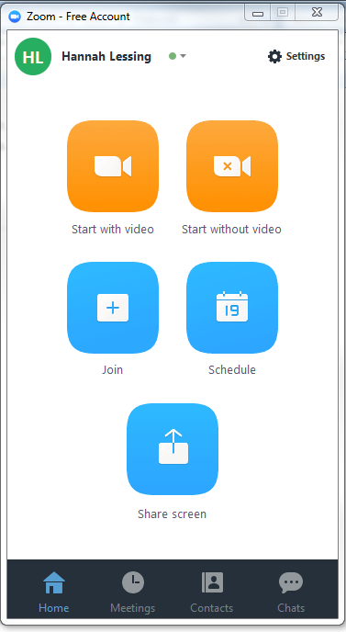
Joining the meeting
1. From the desktop application, you can join a meeting. Since all ADAPT meetings will be pre-arranged, click on “Join” and click on the appropriate meeting.
2. When joining, you will be prompted to join by computer audio. Click on the green button.
3. Upon arrival of participants and affirmation of consent, begin AUDIO RECORDING session.

Review of Zoom features
Note: Depending on what device you use or the formatting of your screen (full, gallery mode, etc.), these may appear differently.

- Mute button: Select to mute your own audio line. Click again to unmute.
- Stop video: Select to stop streaming video. This does not mean you have left the meeting, just that you can no longer be seen.
- Invite: This setting cannot be disabled, but should not be utilized. Participants have been asked to not invite others to this meeting.
- Participants: Once clicked, you can see the list of members in the group to the right hand side of your screen. This will be where you can individually mute participant’s lines or temporarily remove them from meeting if needed.
- Share screen: Due to confidentiality and privacy concerns, this feature is disabled for participants. Only clinicians have the capability to share screens or other material to group members.
  - Once clicked, you will be asked to select a “screen” for sharing.
- Chat: Due to confidentiality and privacy concerns, this feature is disabled and should not be utilized.
- Record: Only the therapist has the capability to record the session. Ensure you hit record at the start of session after affirming with all members their consent to record.
- Leave meeting: Select to end meeting. This will end the meeting for all participants.
- Whiteboard: REMINDER TO BE MINDFUL OF PARTICIPANT VIDEO WINDOWS AND NOT TO TAKE UP WHOLE SCREEN

